EARLY BIRD
-AVAILABLE FROM 3PM ONWARDS-

Choice of Sandwiches €6.00
Available with Filling of your choice (1,5,6)

Toasted Sandwiches €7.00
Available with Filling of your choice (1,5,6)

Soup of the Day €6.50
Please ask your server, served with brown bread (1,5,6,7,9,11)

Today’s Specials €17.95
Please ask your server for today’s specials (allergens change daily)

Chicken Curry €18.70
Medium Spice Creamy Curry Sauce, Cubes of Chicken Breast, Baby Sweetcorn, Cashew Nut
& Fresh Coriander, served with Scented Basmati Rice & Garlic Naan (1,6,7)

Chicken Fajita Burrito €17.50
Marinated Chicken Breast Strips, Wok Fried Mixed Pepper, Slice Green Onions, Black Beans,
Basmati Rice, Wrapped in a Floury Tortilla & Served with Hand Cut Chips (1,12)

STARTERS
-AVAILABLE FROM 4PM ONWARDS-

Goats Cheese Tart €8.00
Goats Cheese & Roast Vegetable Puff Pastry Tart with Cranberry & Orange Relish (1,5,6)
Gluten Free Version Available on Request

Fisherman’s Basket €9.00
Tempura Shrimp & Cod Bites Served with Salad Garnish, Green Pesto & Caper Mayonnaise
(1,2,4,5,6)

Garlic Mushrooms €8.00
Golden Fried Mushrooms served with Salad & Garlic & Chive Mayo (1,5,6)

Chilli Chicken Strips €8.00
Chicken Strips with Sweet Chilli Mayo Dip & Seasoned Salad (1,5,6)

Melon & Parma Ham Platter €8.00
Honeydew & Cantalope Melon Platter with Rosette of Parma Ham, Sorbet & Fruit Coulis

MAINS

Roasted Jerk Chicken €19.70
Marinated Split Roasted Half Chicken, Pickle Cabbages, Julienne Carrot & Cucumber Slaw, Cardamom & Clove Scented Basmati Rice, Lime & Coriander Sauce (12)

Turkey Cordon Bleu €19.95
Escallops of Turkey Breast, Stuffed with ‘Waldrons’ Honey Glaze Ham, St Kevin Brie, Coated
with Gluten Free Breadcrumb, Hasselback Parsnip, Brussel Sprout & Red Wine
& Cranberry Jus (5,6,12)

Pan-Seared Atlantic Salmon €21.95
Seared Atlantic Salmon, Garlic & Sage Butter Asparagus, Butternut Squash Puree, Hasselback Rooster Potato & Dill Beurre Blanc (2,6,9)

Pan- Fried ‘Herterich’ Pork Chop €17.95
Basted Pork Chop, Sesame Green Beans, Slightly Roasted Vine Tomato, Thyme & Rosemary
Confit of Potato, Apple Cider & Honey Glaze (6,11,12)

Buttermilk Chicken Burger €17.95
Crispy Coated Butterfly Chicken Breast, Rocket Leaf, Beef Tomato, Feta Cheese, Chipotle Mayonnaise, Brioche Bun, served with Hand Cut Chips (1,5,6)

Castlemine Farm Beef Burger €17.95
7oz Castlemine Farm Beef Mince, Pickle Cucumber, Swiss Cheese, Mustard Aioli, Green Lettuce, Tomato, Smokey Rasher, Onion Brioche Bun, Served with Hand Cut Chips (1,5,6,9,10)

Fish & Chips €18.70
Crispy Coated Fresh White Fish, Tartare Sauce, Crust Parsley Peas & Served with
Hand Cut Chips (1,2,6,13)

8 OZ Sirloin Steak €26.70
Grilled 8oz Sirloin Steak, Tempura of Onion Rings, Baked Garlic Portobello Mushroom,
Cognac & Black Pepper Sauce served with Hand Cut Chips (1,6,12)

Vegan Butternut Squash & Cauliflower Curry €16.95
Mild Coconut Curry, Fresh Coriander, Fresh Ginger, Roasted Tomato & Butternut Squash,
Cauliflower, Cashew Nut, Served with Poppadum, Cardamon & Clove Scented Basmati Rice (7)

ALL OUR MENU ITEMS ARE SOURCED FROM LOCAL SUPPLIERS

AND ARE FRESHLY PREPARED EACH DAY

Joe Campbell – Beef Waldron’s Meats – Pork & Bacon

Castlemine Farm – Lamb, Beef & Pork Glancy’s – Vegetables

Fullards – Fruit & Vegetables Millhouse Farm – Organic Leaves

Herterich Butchers – Turkey & Beef Starcrest – Fish & Shellfish

B&B Foods – Bacon & Pork Products

SIDES
Julienne Carrot & Cucumber Slaw (5) €3.50
Honeyglaze Hasselback Parsnip (6) €3.50
Tempura of Onion Rings (1,5,6) €3.50
Handcut Chips €3.50
Potato of the Day (6) €3.50
Potato & Vegetables (6) €3.50
Cheese or Garlic Dip (5,6) €1.00
Side Salad (10) €3.50
Hasselback Rooster Potato (6) €3.50
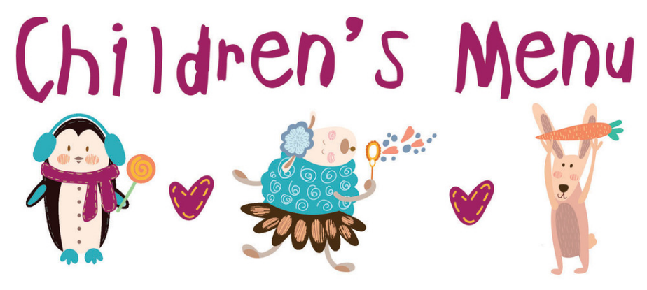

Children’s Joint of the Day with Vegetables and Potatoes (6) €7.80
Mini Beef Burger * (1,5,6) €7.30
Deep-Fried Chicken Goujons* (1,5,6) €7.30
*Served with a choice of French Fries or Potatoes
Penne Pasta with Tomato Sauce (6) €4.70
Vanilla Ice Cream with Chocolate Sauce (6) €3.70
Warm Chocolate Muffin with Ice Cream (1,5,6) €3.70

DESSERTS

Raspberry Ripple Cheesecake €7.80
White Chocolate & Raspberry Ripple Cheesecake with a Berry Coulis & Vanilla Ice Cream
(1,5,6)

Sticky Toffee & Pecan Tartlet €7.80
Baked Sticky Toffee Tartlet with Honeycomb Ice Cream & Butterscotch Sauce (1,5,6,7)

Lemon Panna Cotta €7.80
Lemon Scented Panna Cotta with Mulled Berry Compote, Raspberry Sorbet
& Shortbread Biscuit (5,6) Gluten Free Version Available

Cheeseboard €9.00
A selection of Irish Cheeses served with savoury crackers, Apple, Grapes
& Chutney (1,5,6,9,10) Gluten Free Crackers Available on Request

We do our best to prepare dishes free of certain allergens on request.
However, please note that our kitchen is not entirely allergen free and there may be small traces present.

BEVERAGES

Tea €3.00 Coffee €3.00
Espresso €3.00 Large Coffee €3.40
Café Latte €3.70 Mocha €3.70
Double Espresso €4.00 Irish coffee €6.70
Cappuccino €3.20 Bailey’s Coffee €7.00
Hot Chocolate €3.70 French Coffee €7.20
Speciality Teas €4.00
Glass of House Red/White Wine €6.80

